**Assignment 2**

Task 1: Sales By Customer:

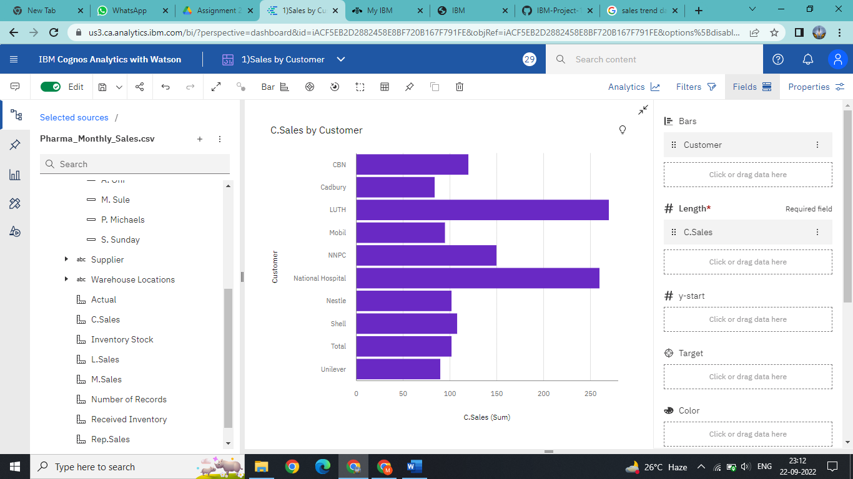

Task 2: Sales By Location:

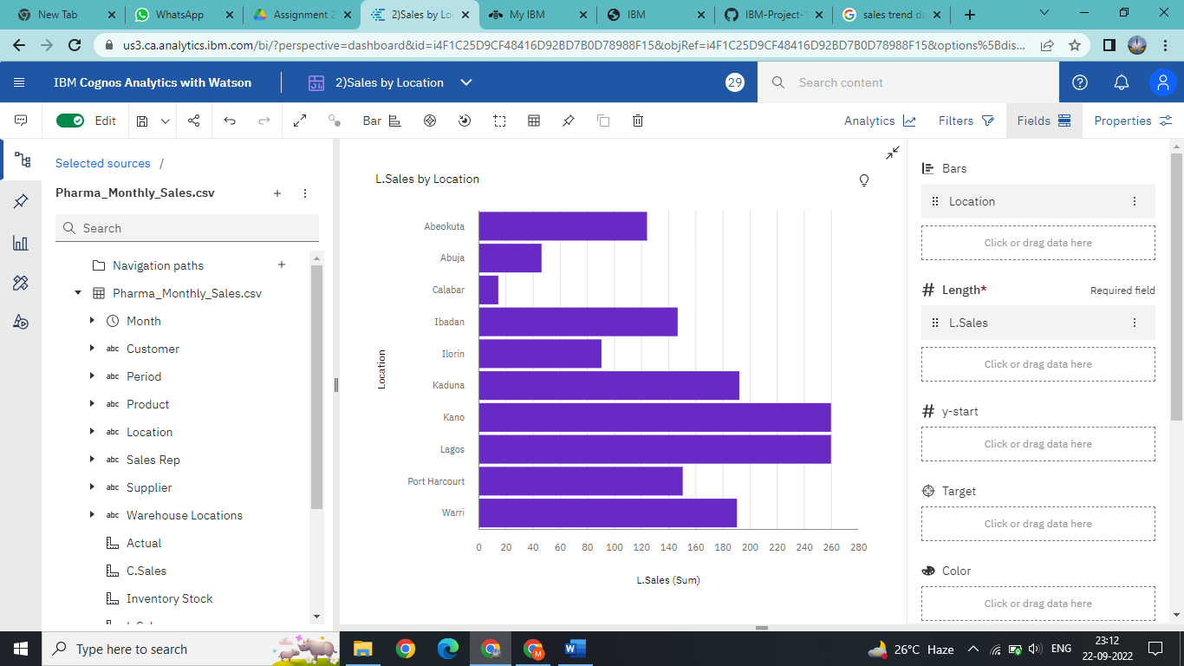

Task 3: Sales By Sales Representative:

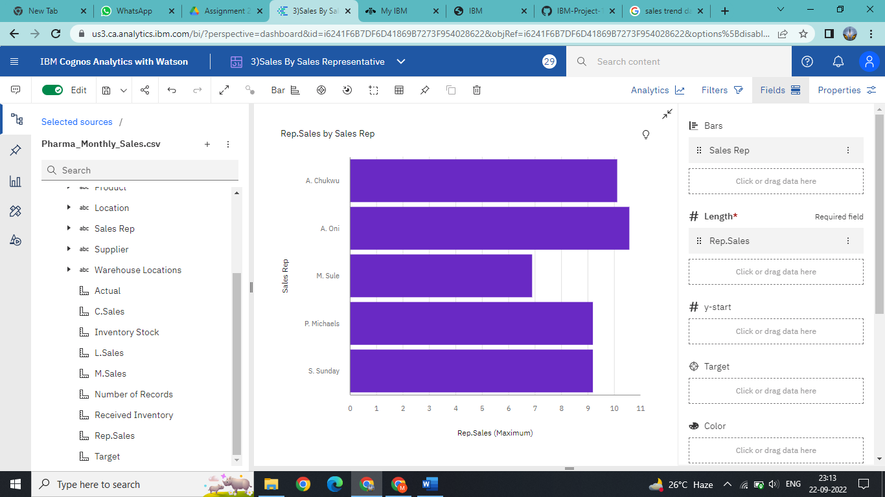

Task 4: Received Inventory From Supplier:

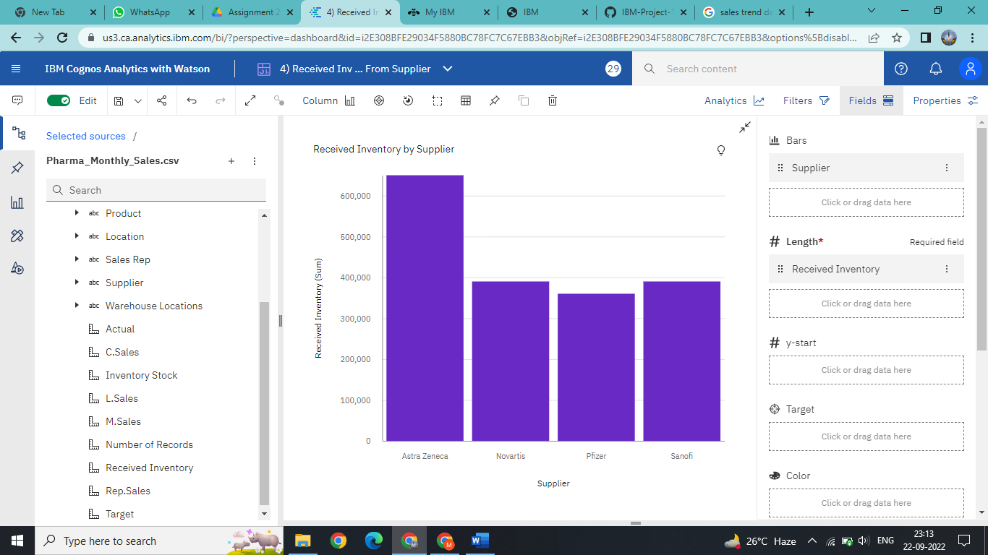

Task 5: Inventory Stock for Warehouse Locations:

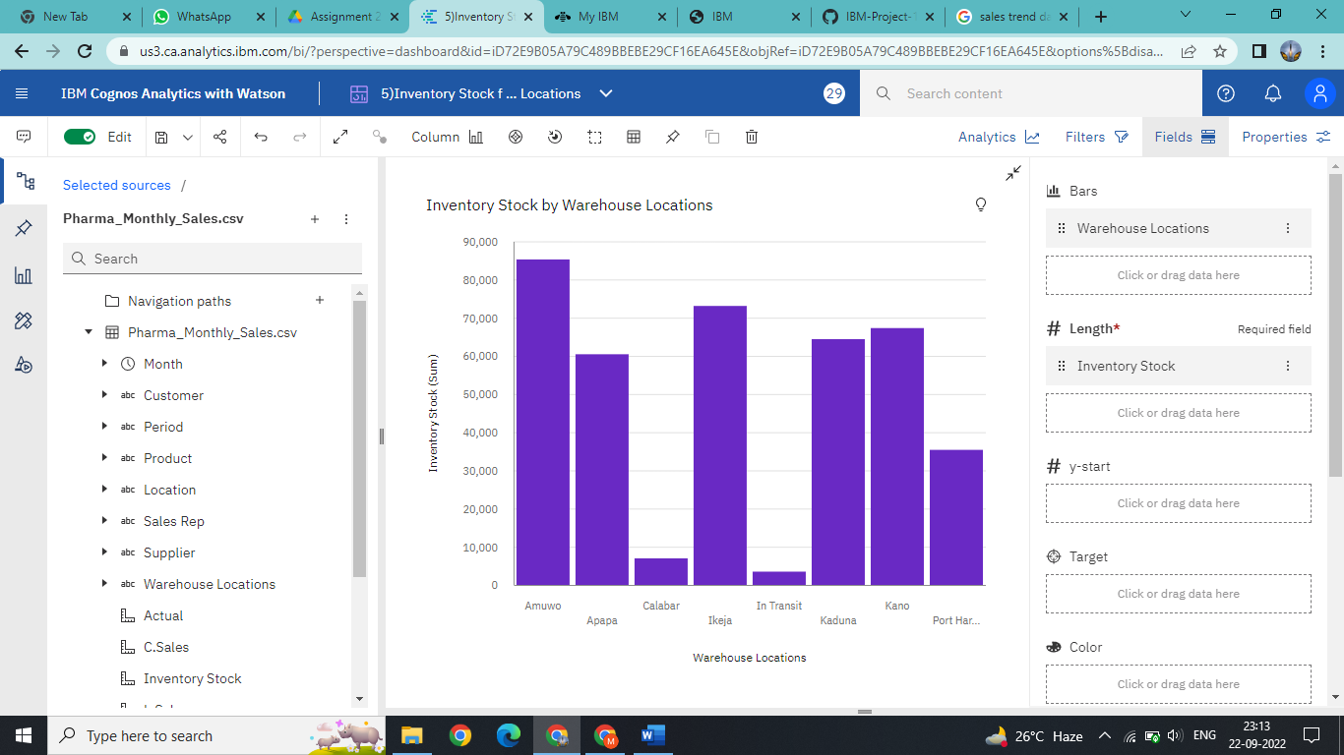

Task 6: Sales Trend:

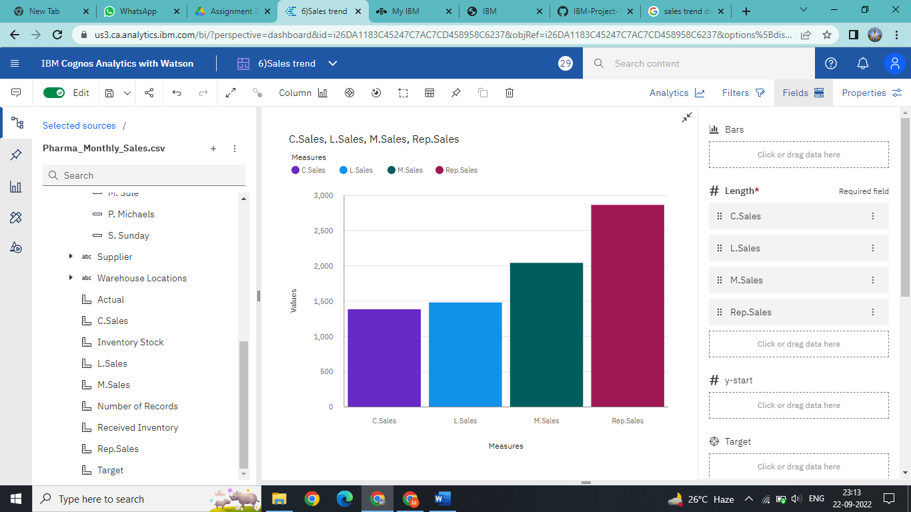

Task 7: Monthly Sales:

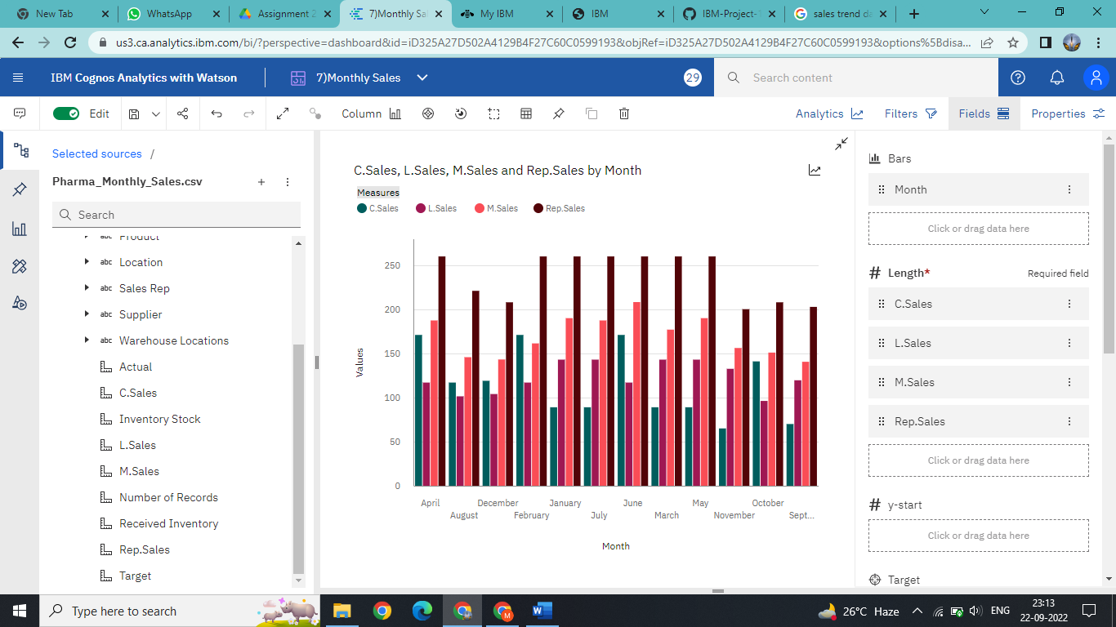

Task 8: Actual and Received Inventory by Month:

